**CSD MINI PROJECT**

1. **ABSTRACT:**

A basic advocate web application (Advo-Get) that helps people to know about lawyers and a way to connect and interact with them. Lawyers can edit, update their profiles anytime and from anywhere by signing in the web application.

1. **INTRODUCTION:**

A lawyer is a professional who is qualified to offer advice about the law or represent someone in legal matters. A lawyer can also be called an attorney, a solicitor, a counsellor, a barrister, or — pejoratively — an ambulance chaser.

A lawyer can handle all sorts of legal matters from drafting wills to patent claims to defending people against criminal charges. Qualified lawyers have to attend law school and pass a bar exam in order to practice law. Lawyer, of course, means one who practices the law.

"Law" itself comes from the Old Norse root word lag, which means something lay down or fixed.

Duties of a lawyer:

A lawyer’s main duties are to uphold the law while protecting a client's rights. Lawyers advise, research, and collect evidence or information, draft legal documents such as contracts, divorces, or real estate transactions, and defend or prosecute in court.

So the project that we decided is based on the advocates, who are they, what their duties, what acts are there are and many more. We will start with a basic webpage which has the basic details of lawyers and login button that will be accessed by the lawyers if they want to edit or add any information. We have different areas like designations, types and if they want to go through these things in details there will be a button which will take to a new page .So for each topic it will take to new page, here we can get the clear information.

1. **EXISTING SYSTEM:**

There is a webpage named as lawyers.com. This website has a clear understanding on lawyers their areas and finding a lawyer. What we are trying to make change and make it unique from that website is that we are adding few more things like acts which give basic idea for everyone who does not know anything. And we are even providing the experience and a graph which shows how many cases did a lawyer win or lose which that website does not contain. And once the client gets satisfied with the information then they proceed to further like contacting them for which we are providing email id and contact number.

1. **REQUIREMENTS:**

**Features:**

* We are providing information about lawyers and different areas, types of lawyers.
* We are providing a login for lawyers to view, update and add their information.

1. **PROBLEM STATEMENT:**

People at this time are facing lot of issues while communicating and to get to know a lawyer as, everyone is been adapted to the online networking. So here is an application where everyone can access through this and have an overview of each lawyer according to their specialization and we can let you know all the corresponding details of every lawyer.

1. **PROPOSED SYSTEM:**

Main Page:

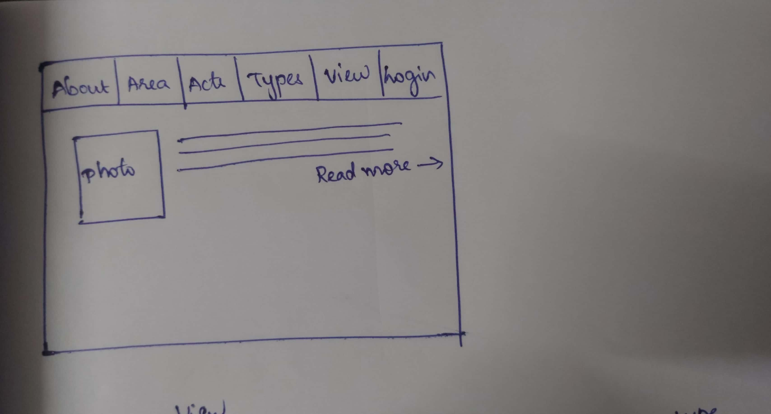

When we click on about it will redirect to a web page that will have information about lawyers.

When we click on Areas it will redirect to other page that will have sub contents given below:

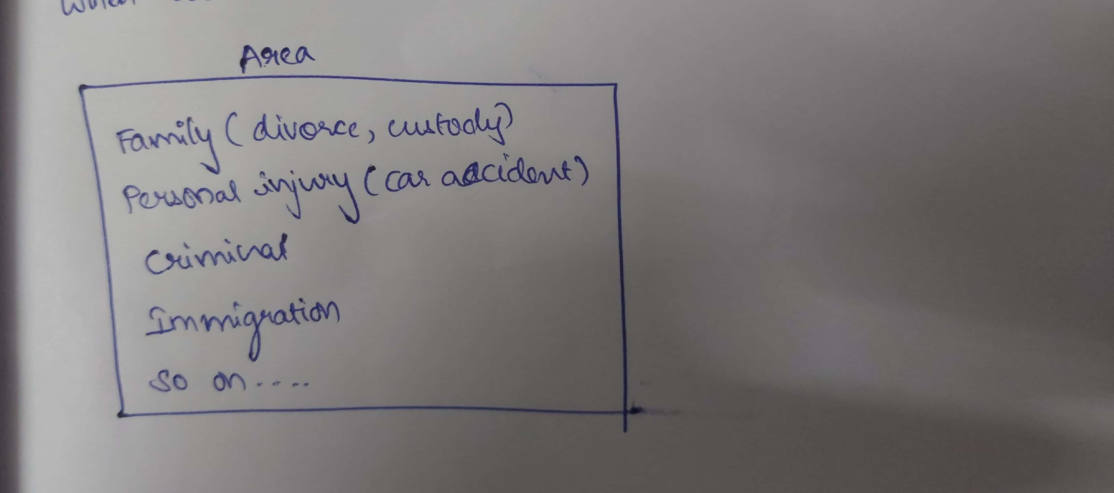

When we click on Acts it will be redirected to other page that consist information related to different acts.

When we click on Types it will be directed to other page that consists of following details:

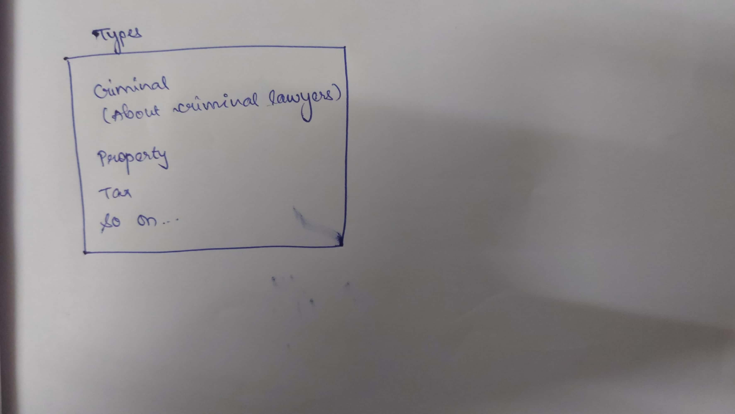

When we click on View it will directed to other page that is as follows:

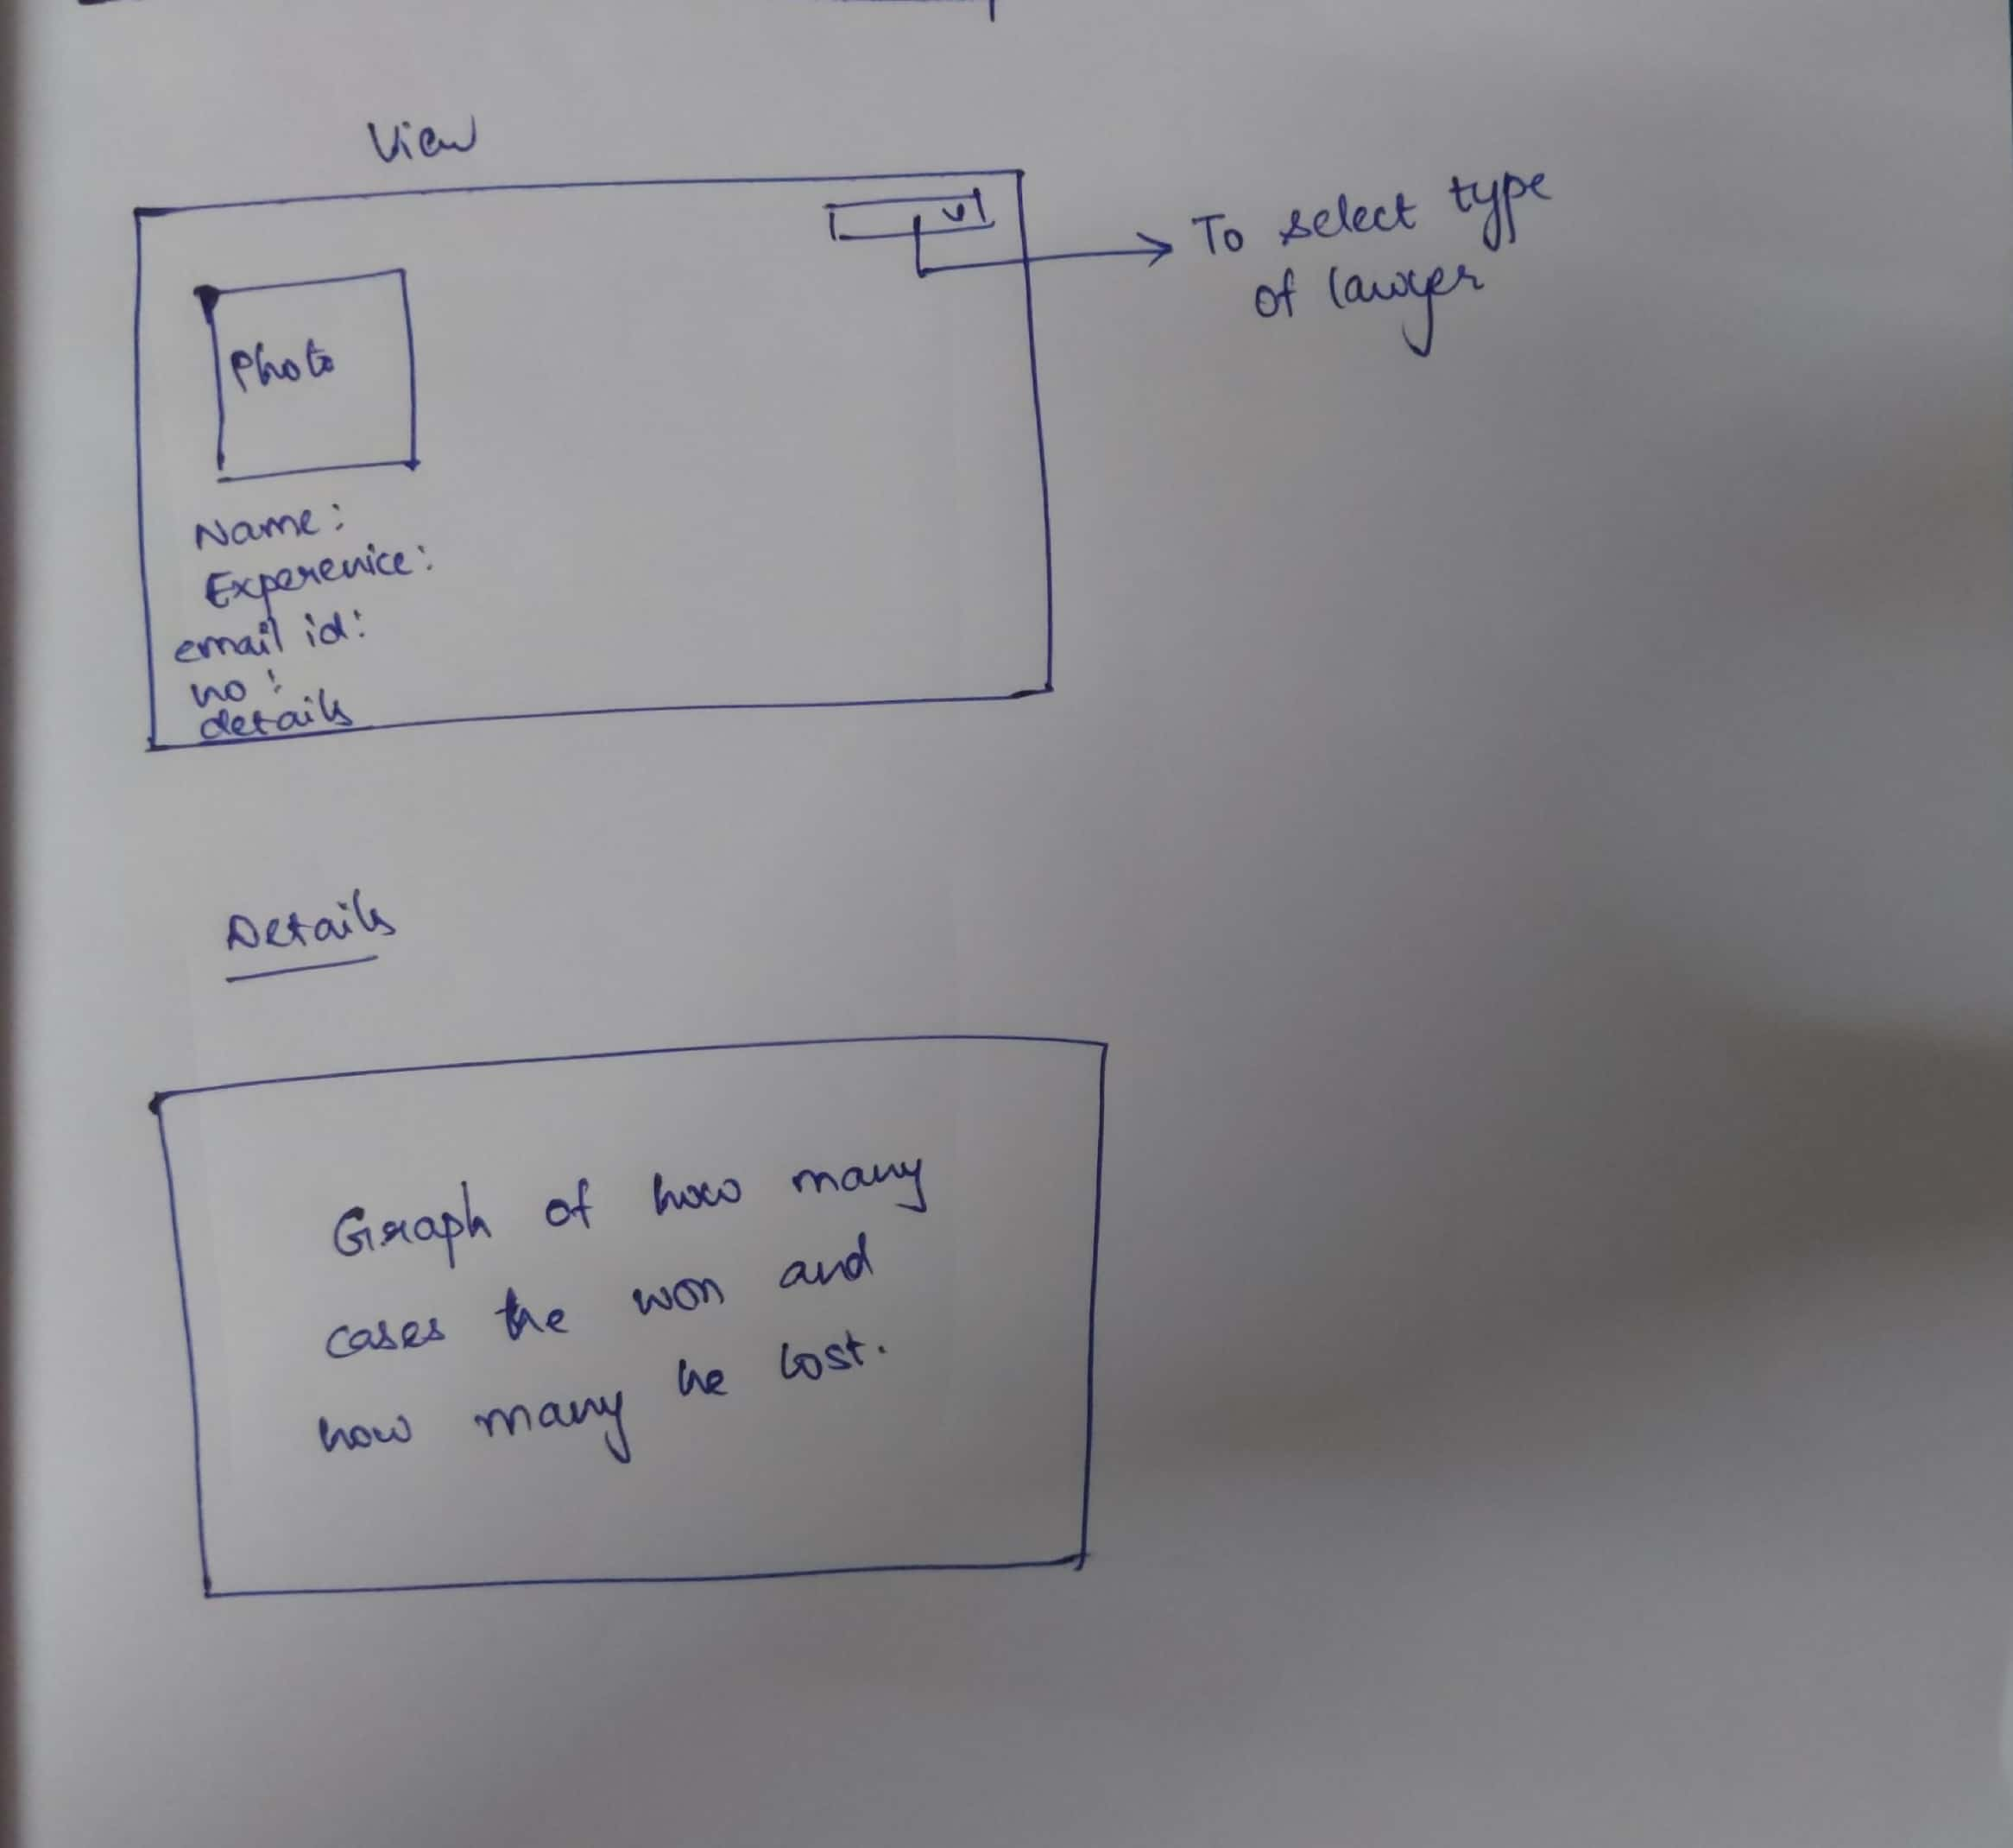

When we click on login(it is only for lawyers):

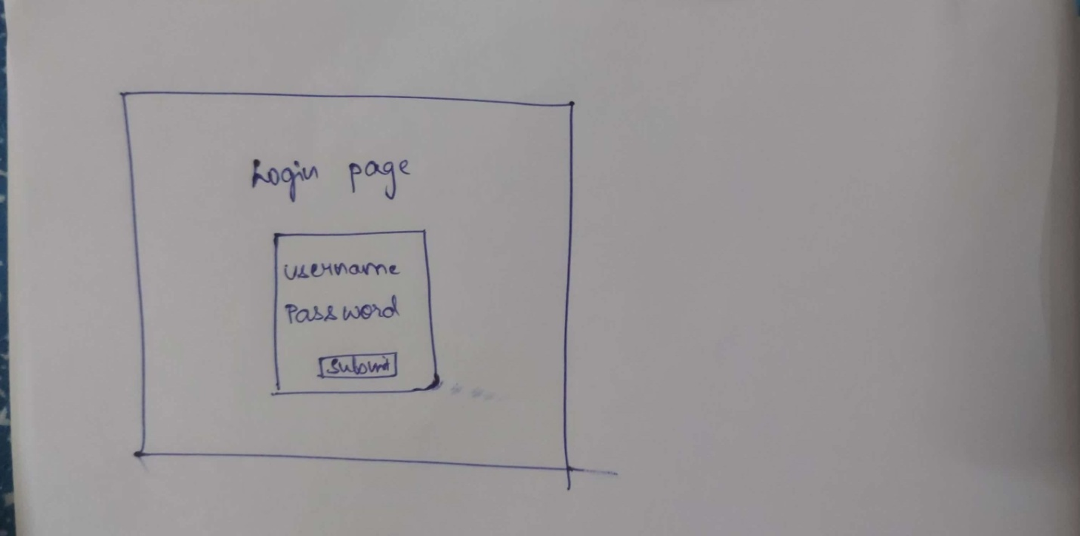

When we click on submit button it will direct to a Lawyers dashboard

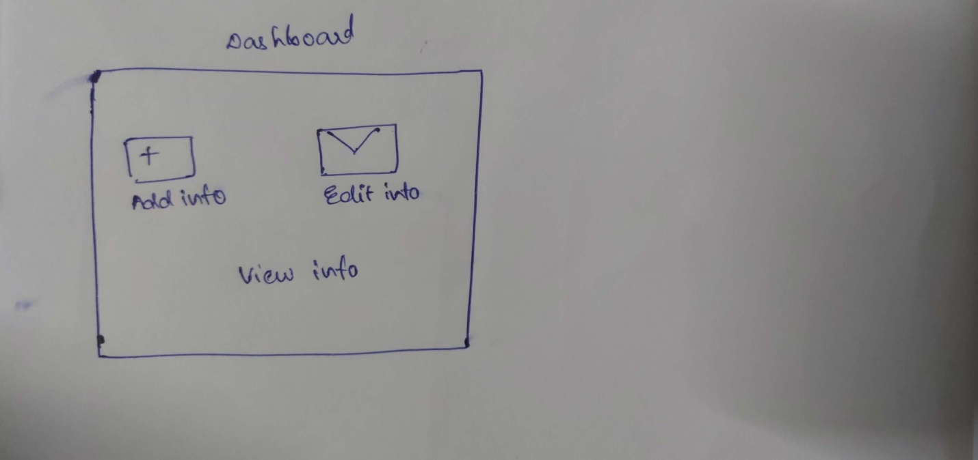

1. **TECHNOLOGY:**

Firstly, to create a web interface we are using HTML, CSS, and JavaScript. Then for database we are using MySQL or Oracle, we are doing database connectivity using Php or Postgresql. Then for analysing the data we will use Machine Learning algorithms.